Acute Rhombohedron

Definition
# Source: AI Source: Provided by: [Data Path: Persons Table -> ID Column: 1, Name_En Column: Motasem Essam] -> From: [ChatGPT] on [7/25/2026]
An Acute Rhombohedron is a three-dimensional parallelepiped with six congruent rhombus-shaped faces in which all three principal inter-edge angles are acute angles (less than ${90}^{∘}$).
It has six identical rhombus faces, twelve equal edges, and eight vertices. Its overall shape is slanted, with no right angles between its three principal edge directions.
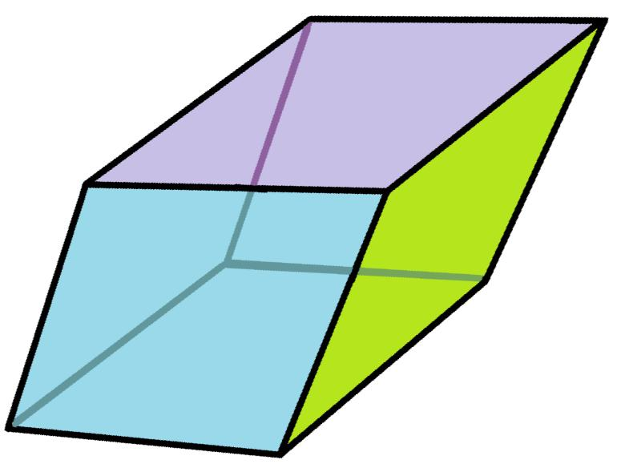

Simple Definition
# Source: AI Source: Provided by: [Data Path: Persons Table -> ID Column: 1, Name_En Column: Motasem Essam] -> From: [ChatGPT] on [7/25/2026]
An acute rhombohedron is a solid with six identical diamond-shaped faces, where the three angles between its main edge directions are all less than ${90}^{∘}$.

Geometric Structure
# Source: AI Source: Provided by: [Data Path: Persons Table -> ID Column: 1, Name_En Column: Motasem Essam] -> From: [ChatGPT] on [7/25/2026]
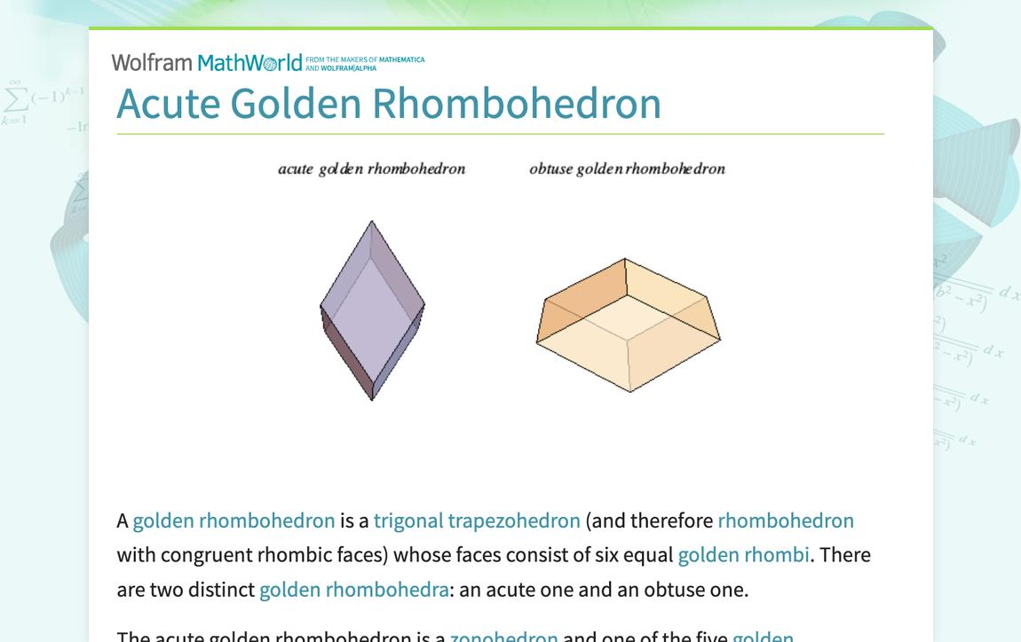
An acute rhombohedron consists of the following elements:
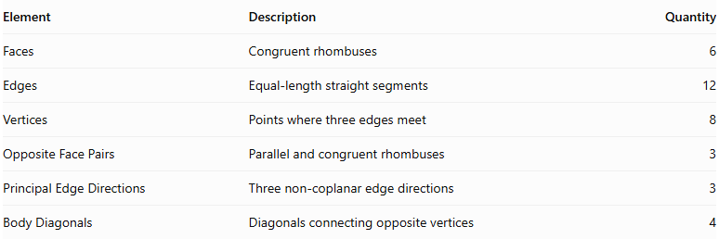
Element | Description | Quantity
Faces | Congruent rhombuses | 6
Edges | Equal-length straight segments | 12
Vertices | Points where three edges meet | 8
Opposite Face Pairs | Parallel and congruent rhombuses | 3
Principal Edge Directions | Three non-coplanar edge directions | 3
Body Diagonals | Diagonals connecting opposite vertices | 4

Main Characteristics

A. Acute Inter-Edge Angles
# Source: AI Source: Provided by: [Data Path: Persons Table -> ID Column: 1, Name_En Column: Motasem Essam] -> From: [ChatGPT] on [7/25/2026]
The defining characteristic is that all three principal angles between the edge directions are acute.
$$\boxed{0^{∘}<α,β,γ<{90}^{∘}}$$
Where:
- $α$ = angle between the first and second edge directions.
- $β$ = angle between the first and third edge directions.
- $γ$ = angle between the second and third edge directions.
These angles are measured between the three principal edge directions, not necessarily between every pair of edges meeting at a vertex.

B. Faces
# Source: AI Source: Provided by: [Data Path: Persons Table -> ID Column: 1, Name_En Column: Motasem Essam] -> From: [ChatGPT] on [7/25/2026]
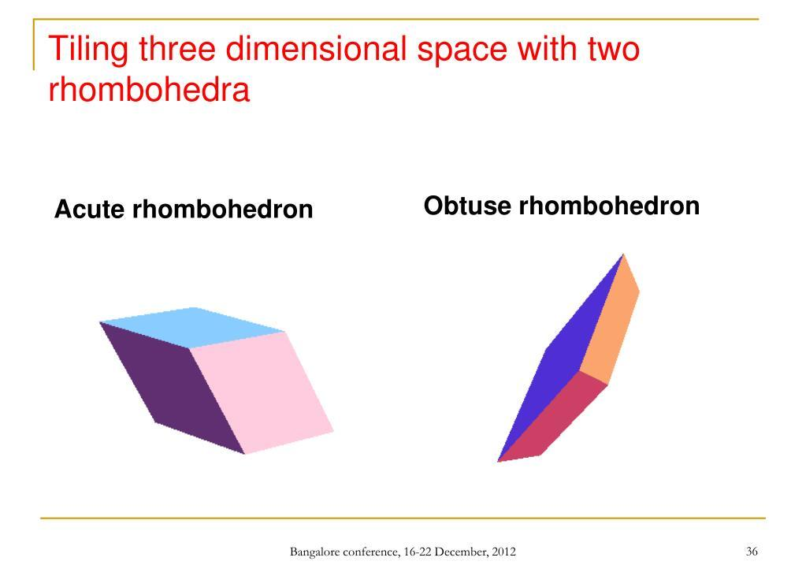
All six faces are congruent rhombuses.
Each face has:
- Four equal sides.
- Two pairs of parallel opposite sides.
- Two acute interior angles.
- Two obtuse interior angles.
The face angles are determined by the angles between the principal edge directions.

C. Edges
# Source: AI Source: Provided by: [Data Path: Persons Table -> ID Column: 1, Name_En Column: Motasem Essam] -> From: [ChatGPT] on [7/25/2026]
An acute rhombohedron has twelve equal edges.
$$\boxed{E=12}$$

D. Vertices
# Source: AI Source: Provided by: [Data Path: Persons Table -> ID Column: 1, Name_En Column: Motasem Essam] -> From: [ChatGPT] on [7/25/2026]
It has eight vertices, with three edges meeting at each vertex.
$$\boxed{V=8}$$

Mathematical Representation
# Source: AI Source: Provided by: [Data Path: Persons Table -> ID Column: 1, Name_En Column: Motasem Essam] -> From: [ChatGPT] on [7/25/2026]
An acute rhombohedron can be described using three equal-length, non-coplanar edge vectors.
Let:
$$|veca|=|vecb|=|vecc|=s$$
Where $s$ is the common edge length.
The angles between the vectors are:
$$α=∠(veca,vecb)$$
$$β=∠(veca,vecc)$$
$$γ=∠(vecb,vecc)$$
For an acute rhombohedron:
$$\boxed{α<{90}^{∘}, β<{90}^{∘}, γ<{90}^{∘}}$$
Its eight vertices can be represented by:
$$O, veca, vecb, vecc,$$
$$veca+vecb, veca+vecc, vecb+vecc, veca+vecb+vecc$$
This representation describes the geometry of the complete parallelepiped.

Mathematical Properties

A. Surface Area
# Source: AI Source: Provided by: [Data Path: Persons Table -> ID Column: 1, Name_En Column: Motasem Essam] -> From: [ChatGPT] on [7/25/2026]
All six faces are congruent rhombuses.
If the common edge length is $s$, and the acute interior angle of each face is $θ$, then:
$$A_{face}=s^{2}sinθ$$
Therefore:
$$\boxed{SA=6s^{2}sinθ}$$

B. Volume
# Source: AI Source: Provided by: [Data Path: Persons Table -> ID Column: 1, Name_En Column: Motasem Essam] -> From: [ChatGPT] on [7/25/2026]
The volume is the absolute value of the scalar triple product of its three edge vectors:
$$V=|veca·(vecb×vecc)|$$
In terms of edge length and inter-edge angles:
$$\boxed{V=s^{3}\sqrt{1+2cosαcosβcosγ-\cos^{2}α-\cos^{2}β-\cos^{2}γ}}$$

C. Euler's Formula
# Source: AI Source: Provided by: [Data Path: Persons Table -> ID Column: 1, Name_En Column: Motasem Essam] -> From: [ChatGPT] on [7/25/2026]
For a convex acute rhombohedron:
$$V-E+F=2$$
Substituting:
$$8-12+6=2$$
Thus, it satisfies Euler's polyhedron formula.

Diagonals
# Source: AI Source: Provided by: [Data Path: Persons Table -> ID Column: 1, Name_En Column: Motasem Essam] -> From: [ChatGPT] on [7/25/2026]
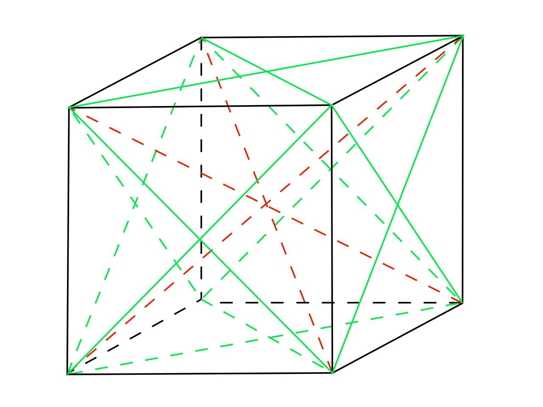
An acute rhombohedron has two important diagonal categories.
A. Face Diagonals
Each rhombus face has two diagonals:
- A shorter diagonal.
- A longer diagonal.
B. Body Diagonals
There are four body diagonals connecting pairs of opposite vertices.
Their lengths are not necessarily equal.
For edge vectors $veca,vecb,vecc$, the four body-diagonal vectors, up to direction, are:
$$veca+vecb+vecc$$
$$-veca+vecb+vecc$$
$$veca-vecb+vecc$$
$$veca+vecb-vecc$$

Symmetry Properties
# Source: AI Source: Provided by: [Data Path: Persons Table -> ID Column: 1, Name_En Column: Motasem Essam] -> From: [ChatGPT] on [7/25/2026]
An acute rhombohedron has:
- A center of symmetry at the intersection of its body diagonals.
- Three pairs of parallel opposite faces.
- Three pairs of opposite vertices.
- Central inversion symmetry.
A general acute rhombohedron does not necessarily have mirror symmetry planes.

Worked Mathematical Examples

Example 1: Finding the Surface Area
# Source: AI Source: Provided by: [Data Path: Persons Table -> ID Column: 1, Name_En Column: Motasem Essam] -> From: [ChatGPT] on [7/25/2026]
An acute rhombohedron has an edge length of $5 cm$, and each rhombus face has an acute interior angle of ${60}^{∘}$.
Find its total surface area.
Solution:
Area of one face:
$$A_{face}=s^{2}sinθ$$
Substitute:
$$A_{face}=5^{2}sin{60}^{∘}$$
$$=25×\frac{\sqrt{3}}{2}$$
Total surface area:
$$SA=6×\frac{25\sqrt{3}}{2}$$
$$\boxed{SA=75\sqrt{3}{ cm}^{2}}$$

Example 2: Finding the Volume
# Source: AI Source: Provided by: [Data Path: Persons Table -> ID Column: 1, Name_En Column: Motasem Essam] -> From: [ChatGPT] on [7/25/2026]
An acute rhombohedron has an edge length of $4 cm$, with all three inter-edge angles equal to ${60}^{∘}$.
Find its volume.
Solution:
Use:
$$V=s^{3}\sqrt{1+2cosαcosβcosγ-\cos^{2}α-\cos^{2}β-\cos^{2}γ}$$
Substitute:
$$V=4^{3}\sqrt{1+2(\frac{1}{2})^{3}-3(\frac{1}{2})^{2}}$$
$$=64\sqrt{1+\frac{1}{4}-\frac{3}{4}}$$
$$=64\sqrt{\frac{1}{2}}$$
$$\boxed{V=32\sqrt{2}{ cm}^{3}}$$

Constructing Acute Rhombohedron in Solid Geometry

Geometric Instruments Used
# Source: AI Source: Provided by: [Data Path: Persons Table -> ID Column: 1, Name_En Column: Motasem Essam] -> From: [ChatGPT] on [7/25/2026]
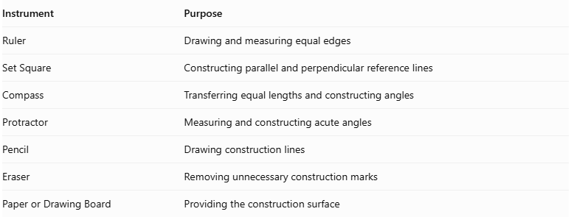
Instrument | Purpose
Ruler | Drawing and measuring equal edges
Set Square | Constructing parallel and perpendicular reference lines
Compass | Transferring equal lengths and constructing angles
Protractor | Measuring and constructing acute angles
Pencil | Drawing construction lines
Eraser | Removing unnecessary construction marks
Paper or Drawing Board | Providing the construction surface

Instrument-Based Construction Procedures

Isometric Construction
# Source: AI Source: Provided by: [Data Path: Persons Table -> ID Column: 1, Name_En Column: Motasem Essam] -> From: [ChatGPT] on [7/25/2026]
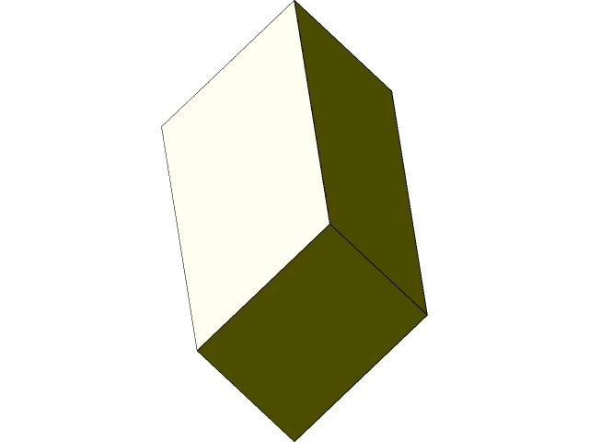
- Select an edge length and three acute principal angles.
- Draw a rhombus representing the bottom face.
- From its vertices, draw equal, parallel inclined edges in the selected third edge direction.
- Ensure the angle between this direction and each of the two base edge directions is acute.
- Connect the upper endpoints to form the opposite rhombus face.
- Complete the remaining faces by connecting corresponding vertices.
- Verify that all twelve edges have equal lengths and all six faces are congruent rhombi.
- Use dashed lines for hidden edges where necessary.

Oblique Projection Construction
# Source: AI Source: Provided by: [Data Path: Persons Table -> ID Column: 1, Name_En Column: Motasem Essam] -> From: [ChatGPT] on [7/25/2026]
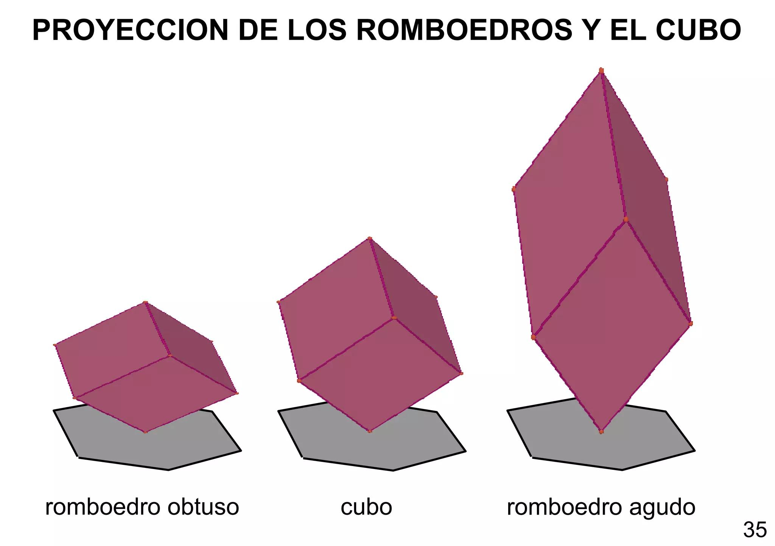
- Draw a rhombus representing the front face.
- Select the direction and inclination of the receding edges.
- Draw equal, parallel receding edges from the four vertices.
- Ensure the resulting principal angles represent an acute rhombohedron.
- Connect the endpoints to construct the opposite rhombus face.
- Complete the remaining edges and faces.
- Check the equality and parallelism of corresponding edges.

Face-Based Construction
# Source: AI Source: Provided by: [Data Path: Persons Table -> ID Column: 1, Name_En Column: Motasem Essam] -> From: [ChatGPT] on [7/25/2026]
- Construct one rhombus face using a ruler and compass.
- Construct five additional congruent rhombi.
- Arrange the faces so that their corresponding edges can be joined.
- Match the six faces along their shared edges.
- Verify that the resulting solid has eight vertices and twelve equal edges.
- Check that the three principal edge-direction angles are acute.

Edge-Based Construction
# Source: AI Source: Provided by: [Data Path: Persons Table -> ID Column: 1, Name_En Column: Motasem Essam] -> From: [ChatGPT] on [7/25/2026]
- Select and mark the required equal edge length.
- Construct three principal edge directions with acute pairwise angles.
- Draw the parallel edges from the appropriate vertices.
- Complete the three sets of opposite parallel edges.
- Connect the vertices to form six rhombus faces.
- Verify the edge lengths, face congruence, and principal angles.

Net-Based Construction
# Source: AI Source: Provided by: [Data Path: Persons Table -> ID Column: 1, Name_En Column: Motasem Essam] -> From: [ChatGPT] on [7/25/2026]
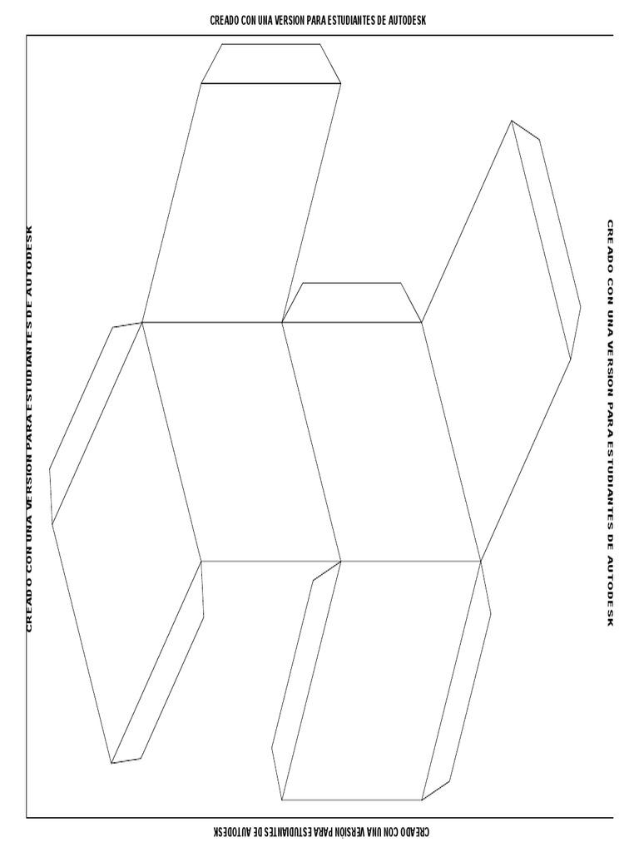
- Draw six congruent rhombi with equal side lengths.
- Arrange the rhombi in a connected net suitable for folding.
- Ensure that adjacent faces share edges of equal length.
- Add tabs if the net is intended for physical assembly.
- Cut and fold the net along the shared edges.
- Join the faces to form the acute rhombohedron.

Real-World Applications
# Source: AI Source: Provided by: [Data Path: Persons Table -> ID Column: 1, Name_En Column: Motasem Essam] -> From: [ChatGPT] on [7/25/2026]
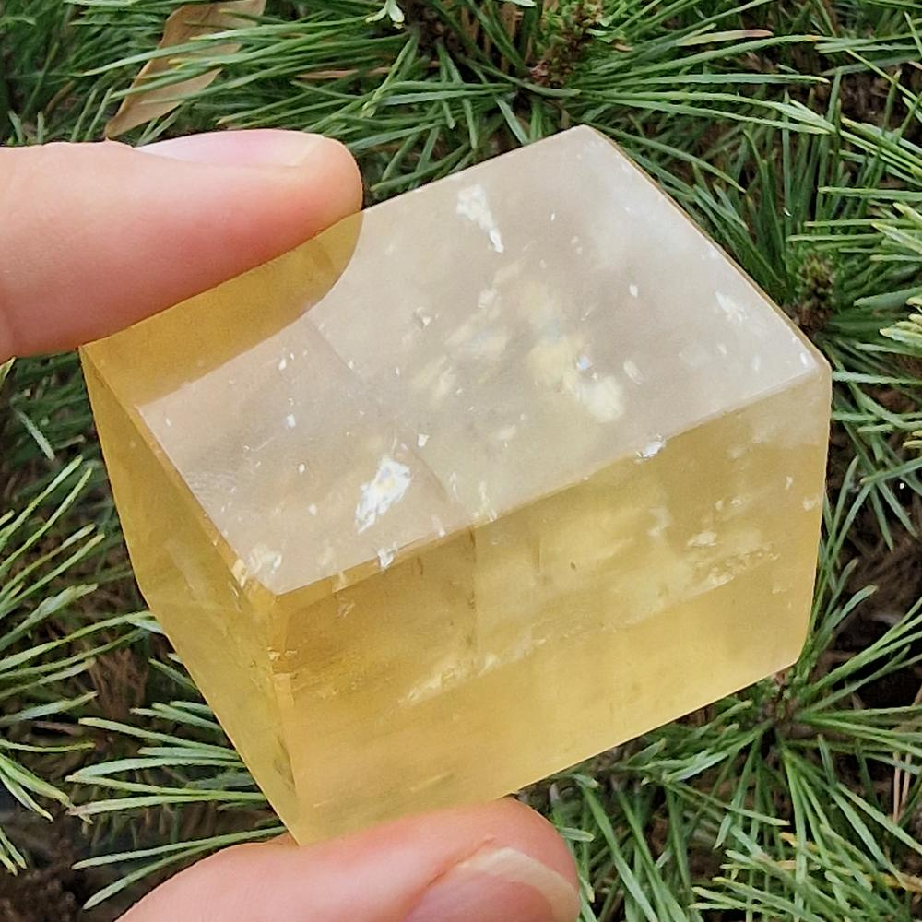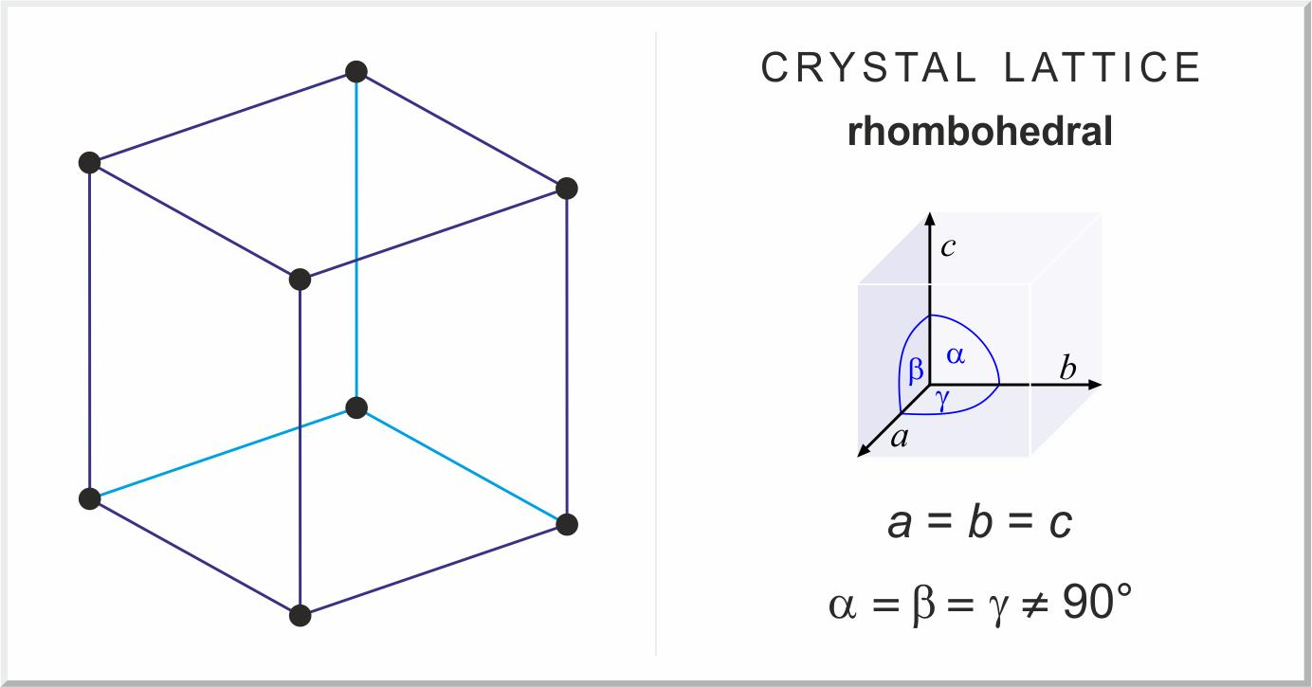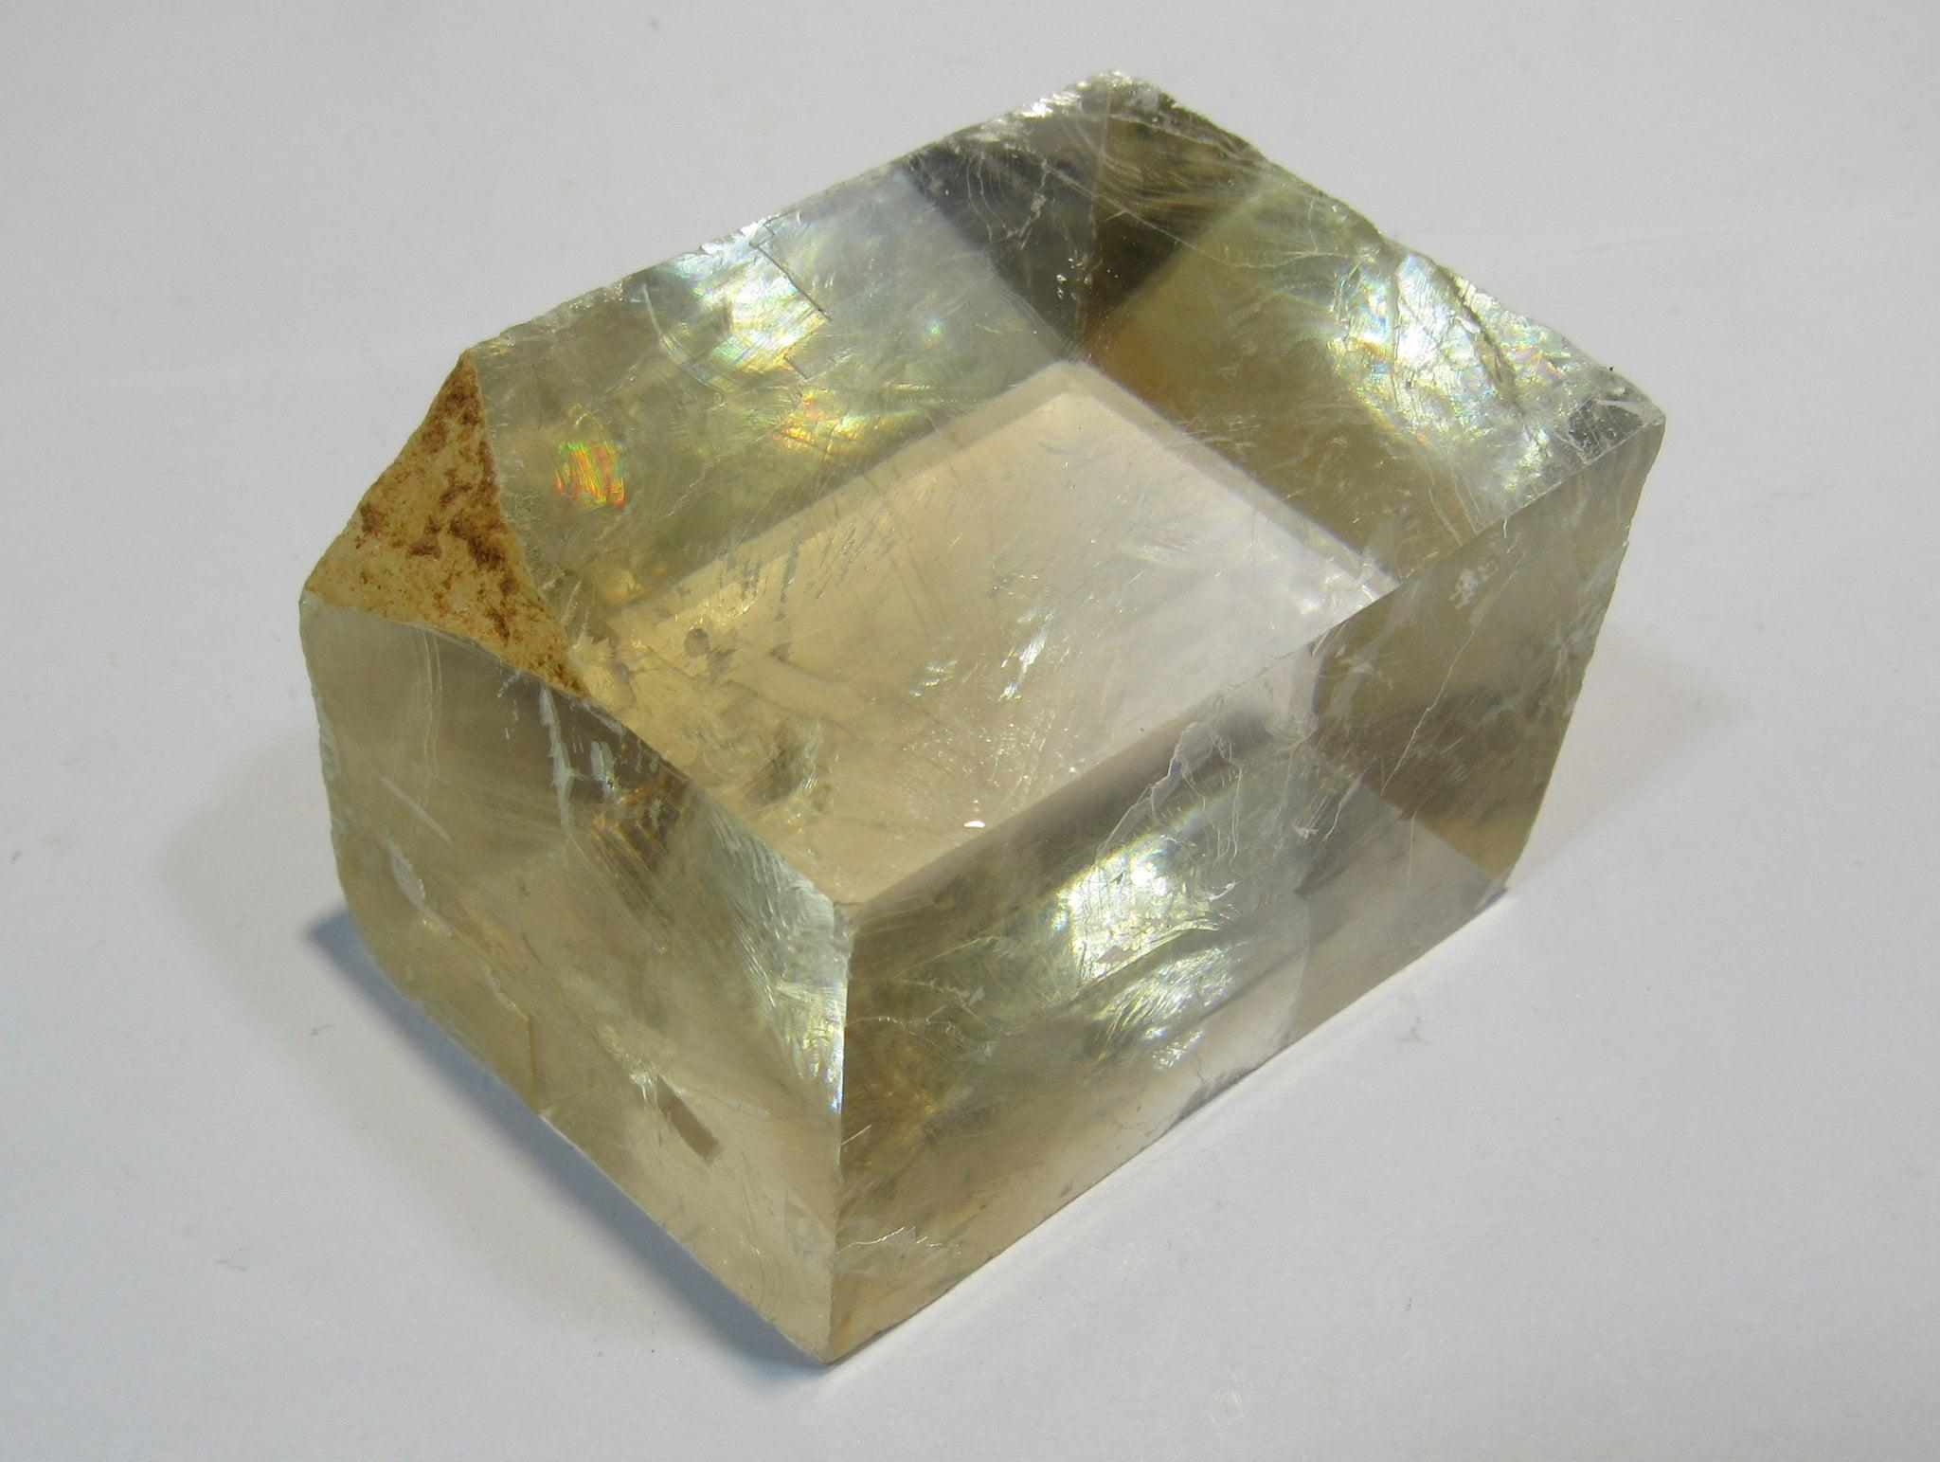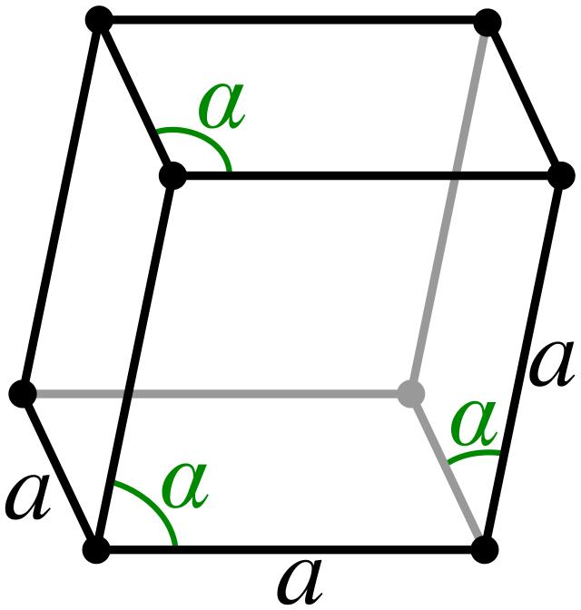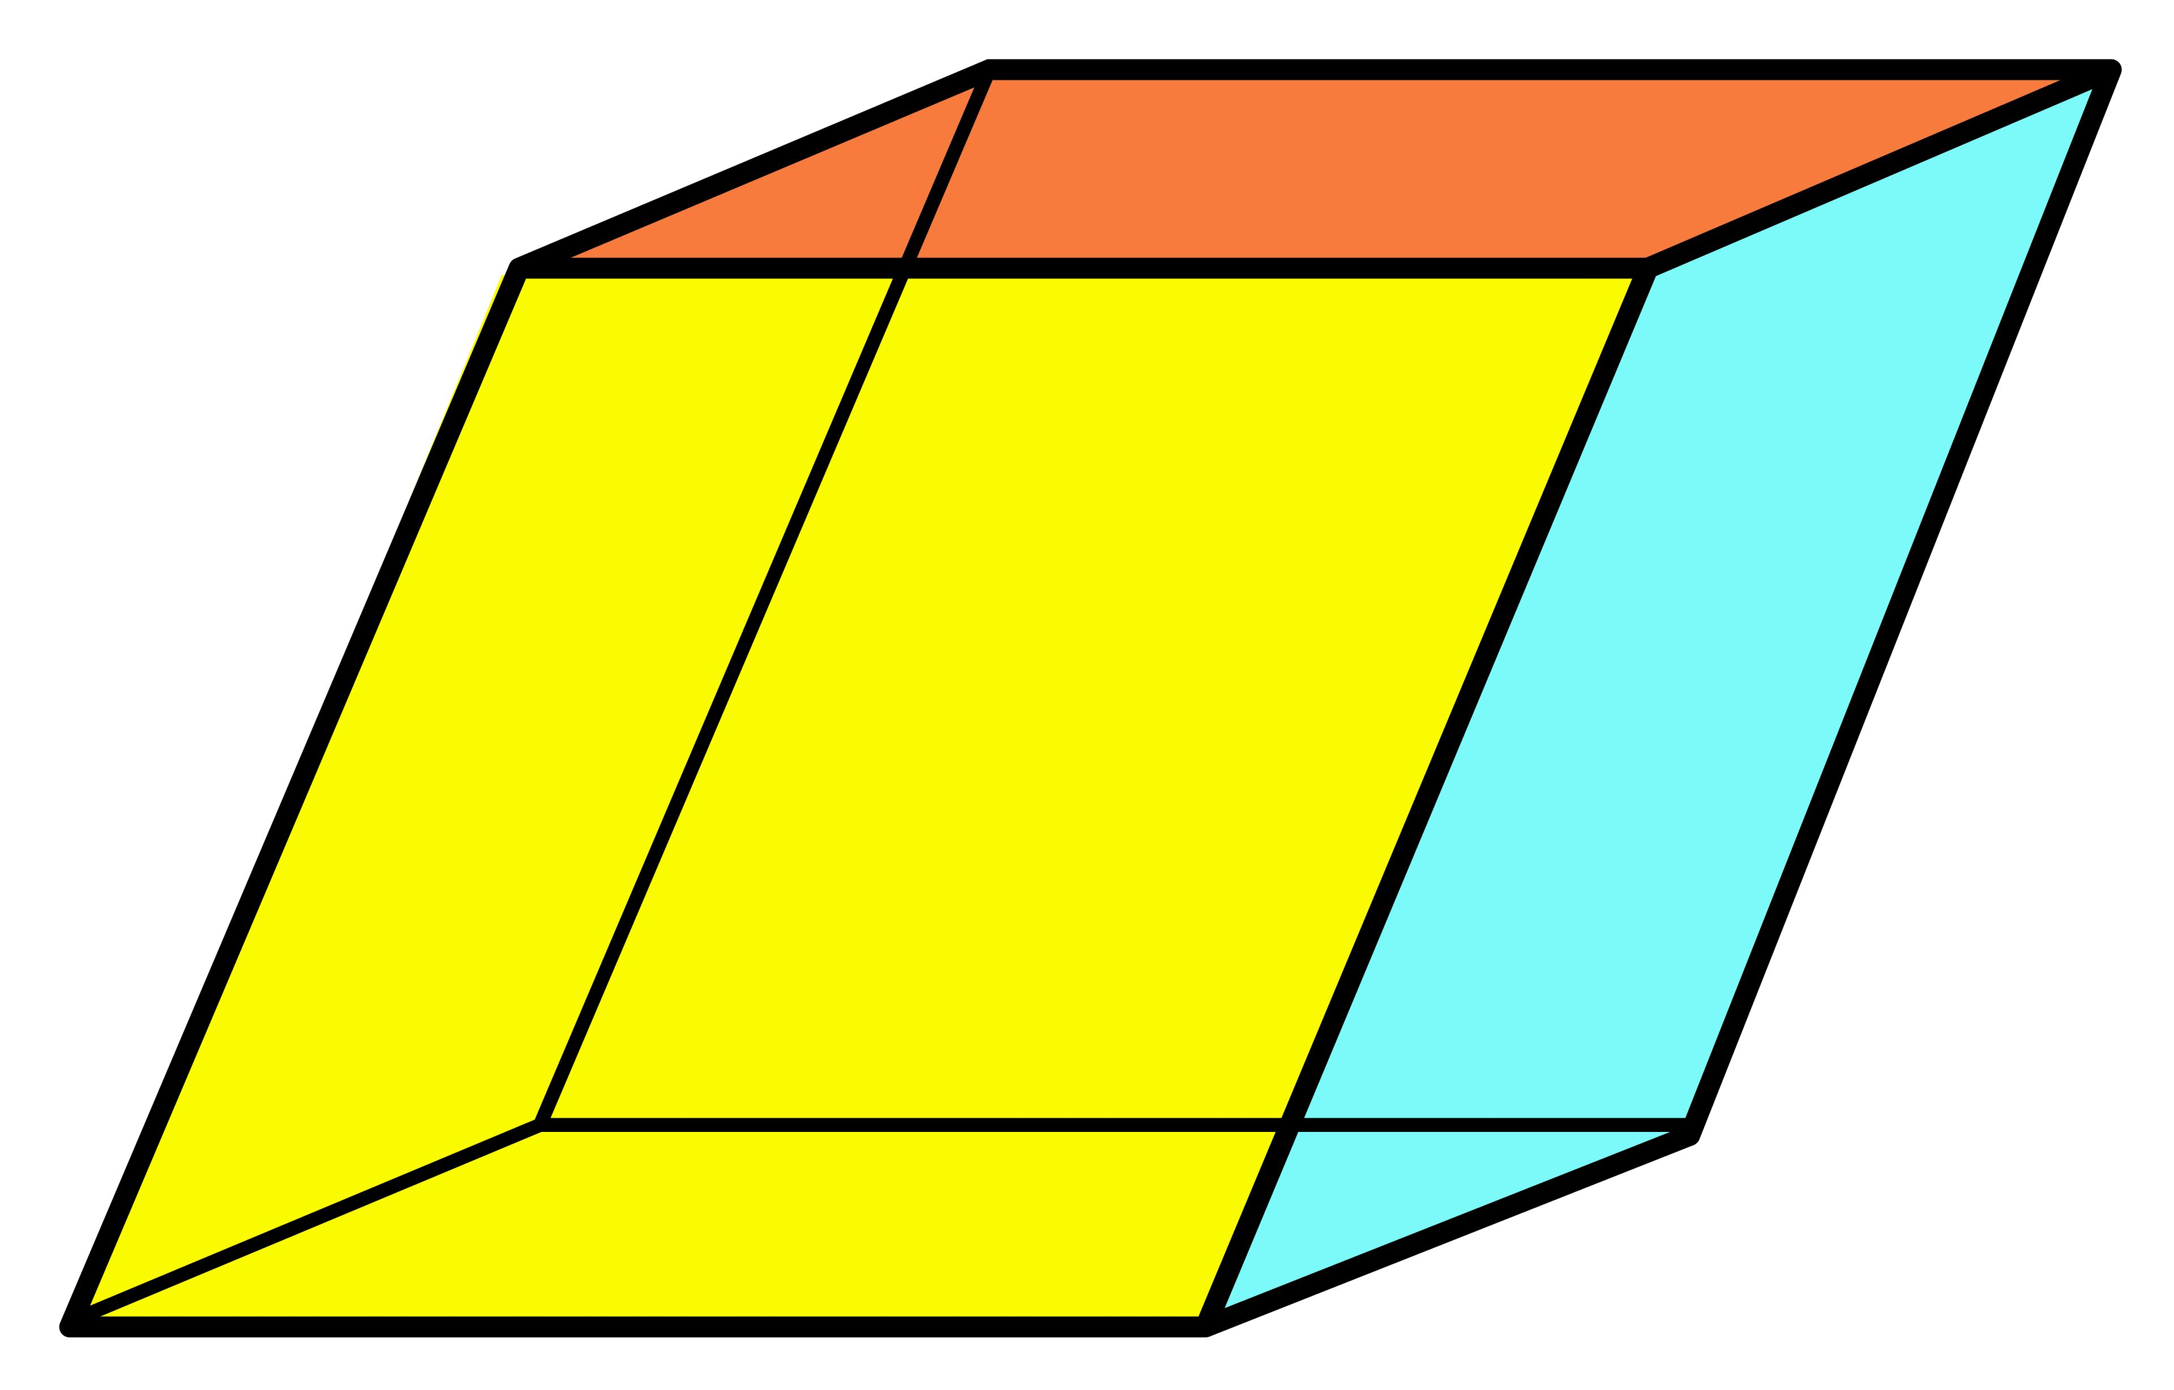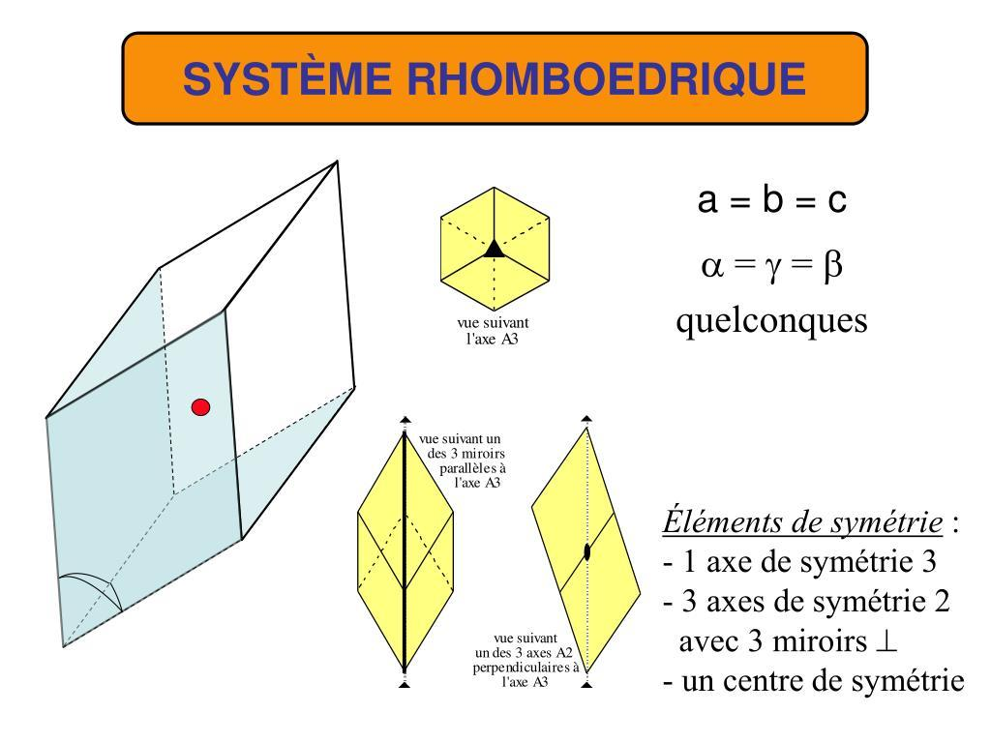
Acute rhombohedra are relevant in:
- Crystallography: Describing rhombohedral unit-cell geometry.
- Mineralogy: Studying crystal shapes and mineral structures.
- Geometric Modeling: Representing three-dimensional parallelepipeds.
- Mathematical Geometry: Studying spatial angles, vectors, and solid volumes.

Comparison with Other Rhombohedra
# Source: AI Source: Provided by: [Data Path: Persons Table -> ID Column: 1, Name_En Column: Motasem Essam] -> From: [ChatGPT] on [7/25/2026]
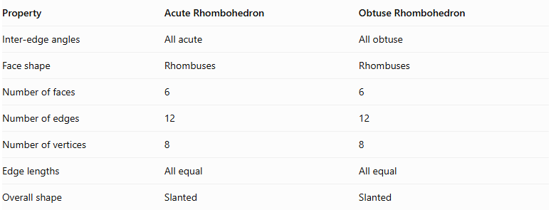
Property | Acute Rhombohedron | Obtuse Rhombohedron
Inter-edge angles | All acute | All obtuse
Face shape | Rhombuses | Rhombuses
Number of faces | 6 | 6
Number of edges | 12 | 12
Number of vertices | 8 | 8
Edge lengths | All equal | All equal
Overall shape | Slanted | Slanted
Note: The three inter-edge angles of a nondegenerate rhombohedron cannot be mixed arbitrarily. The acute and obtuse classifications refer to all three angles between its principal edge directions.

Key Points
# Source: AI Source: Provided by: [Data Path: Persons Table -> ID Column: 1, Name_En Column: Motasem Essam] -> From: [ChatGPT] on [7/25/2026]
- An acute rhombohedron is a special type of parallelepiped.
- It has six congruent rhombus-shaped faces.
- It has twelve equal edges and eight vertices.
- All three principal inter-edge angles are acute.
- Its opposite faces are parallel.
- It has four body diagonals.
- Its volume can be calculated using the scalar triple product.
- It has central symmetry but does not necessarily have mirror symmetry planes.

Conclusion
# Source: AI Source: Provided by: [Data Path: Persons Table -> ID Column: 1, Name_En Column: Motasem Essam] -> From: [ChatGPT] on [7/25/2026]
The Acute Rhombohedron is a three-dimensional geometric solid characterized by six congruent rhombus faces and three acute angles between its principal edge directions. It is a special type of parallelepiped with twelve equal edges, eight vertices, and a center of symmetry. Its geometric properties make it useful in crystallography, mineralogy, vector geometry, and three-dimensional mathematical modeling.

